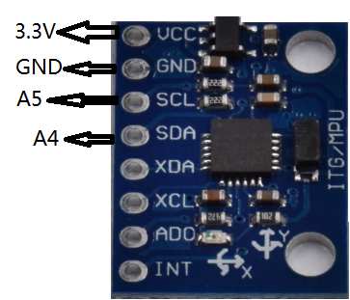

CODE:
/*This is our website www.weikedz.com
For bulk orders, please feel free to contact
sophie@weikedz.com. If any question, for orders,
for technical problems, pls contact us.
We will response you fastest time. */
// Arduino Wire library is required if I2Cdev I2CDEV_ARDUINO_WIRE implementation
// is used in I2Cdev.h
#include "Wire.h"

// I2Cdev and MPU6050 must be installed as libraries, or else the .cpp/.h files
// for both classes must be in the include path of your project
#include "I2Cdev.h"
#include "MPU6050.h"

// class default I2C address is 0x68
// specific I2C addresses may be passed as a parameter here
// AD0 low = 0x68 (default for InvenSense evaluation board)
// AD0 high = 0x69
MPU6050 accelgyro;

int16_t ax, ay, az;
int16_t gx, gy, gz;

#define LED_PIN 13
bool blinkState = false;

void setup() {
// join I2C bus (I2Cdev library doesn't do this automatically)
Wire.begin();

// initialize serial communication
// (38400 chosen because it works as well at 8MHz as it does at 16MHz, but
// it's really up to you depending on your project)
Serial.begin(38400);

// initialize device
Serial.println("Initializing I2C devices...");
accelgyro.initialize();

// verify connection
Serial.println("Testing device connections...");
Serial.println(accelgyro.testConnection() ? "MPU6050 connection successful" : "MPU6050 connection failed");

// configure Arduino LED for
pinMode(LED_PIN, OUTPUT);
}

void loop() {
// read raw accel/gyro measurements from device
accelgyro.getMotion6(&ax, &ay, &az, &gx, &gy, &gz);

// these methods (and a few others) are also available
//accelgyro.getAcceleration(&ax, &ay, &az);
//accelgyro.getRotation(&gx, &gy, &gz);

// display tab-separated accel/gyro x/y/z values
Serial.print("a/g:\t");
Serial.print(ax);
Serial.print("\t");
Serial.print(ay);
Serial.print("\t");
Serial.print(az);
Serial.print("\t");
Serial.print(gx);
Serial.print("\t");
Serial.print(gy);
Serial.print("\t");
Serial.println(gz);

// blink LED to indicate activity
blinkState = !blinkState;
digitalWrite(LED_PIN, blinkState);
}

